**User Manual of HR Module**

* Global Setting

**Skill Types:**

In this UI user can Delete/Add Skill types.

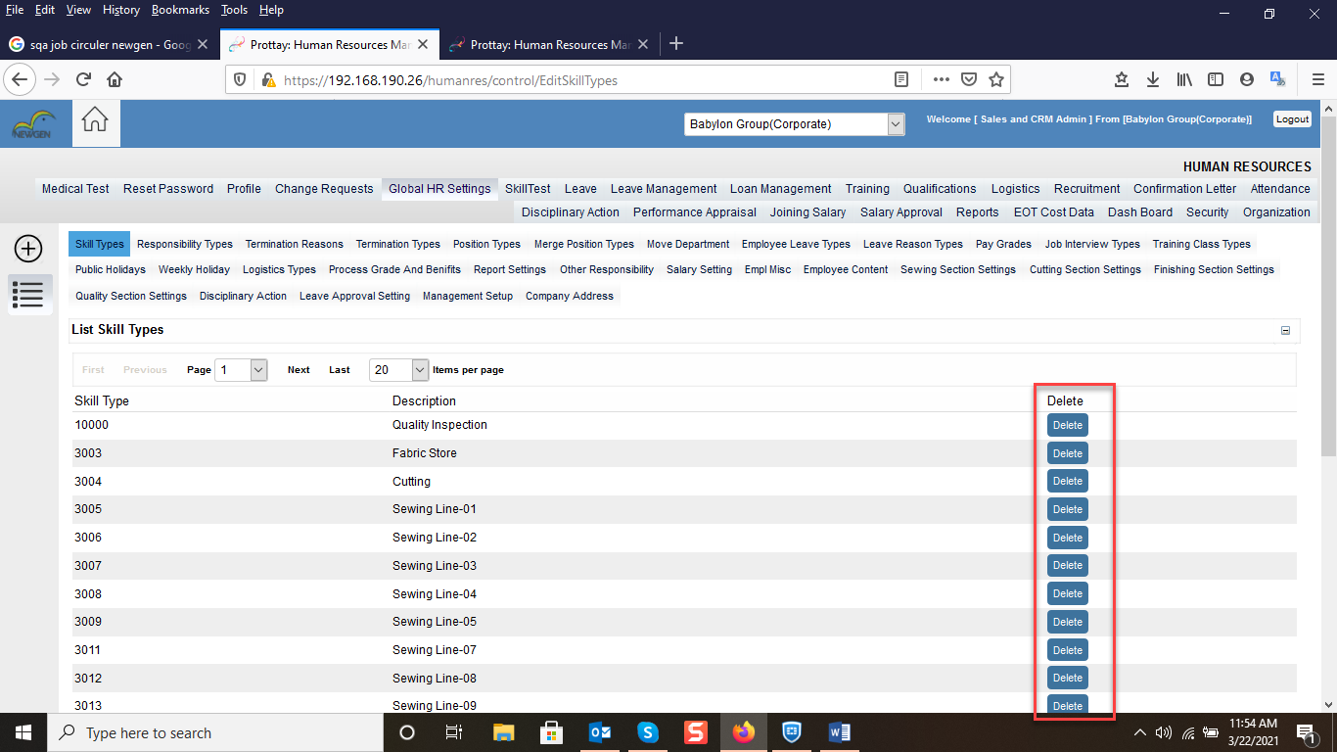

User can Create Skill type by click on the create button. In this section Description Is Required Field and Skill Type System generated Number.

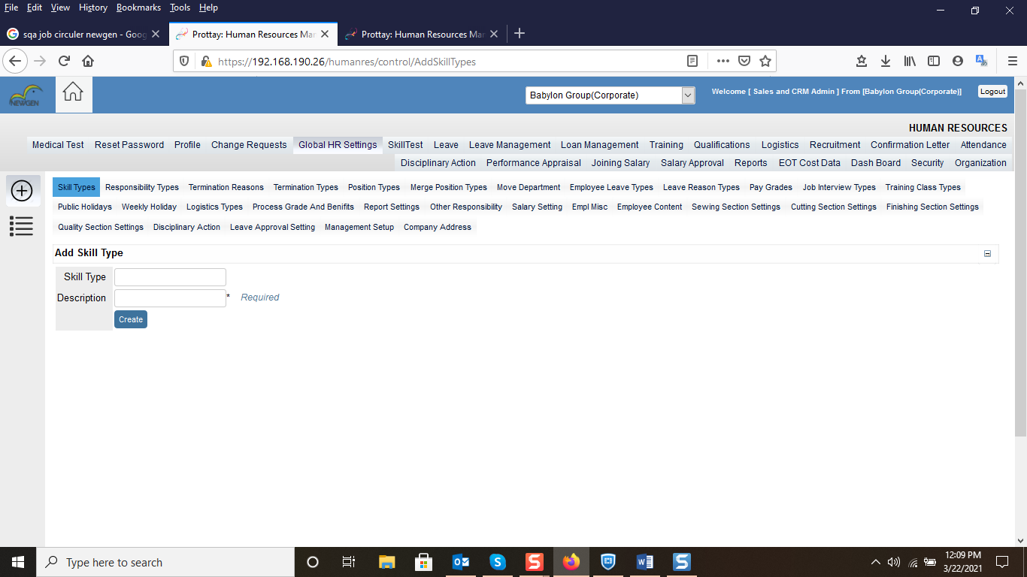

**Responsibility Type:**

User can Create /Delete Responsibility. 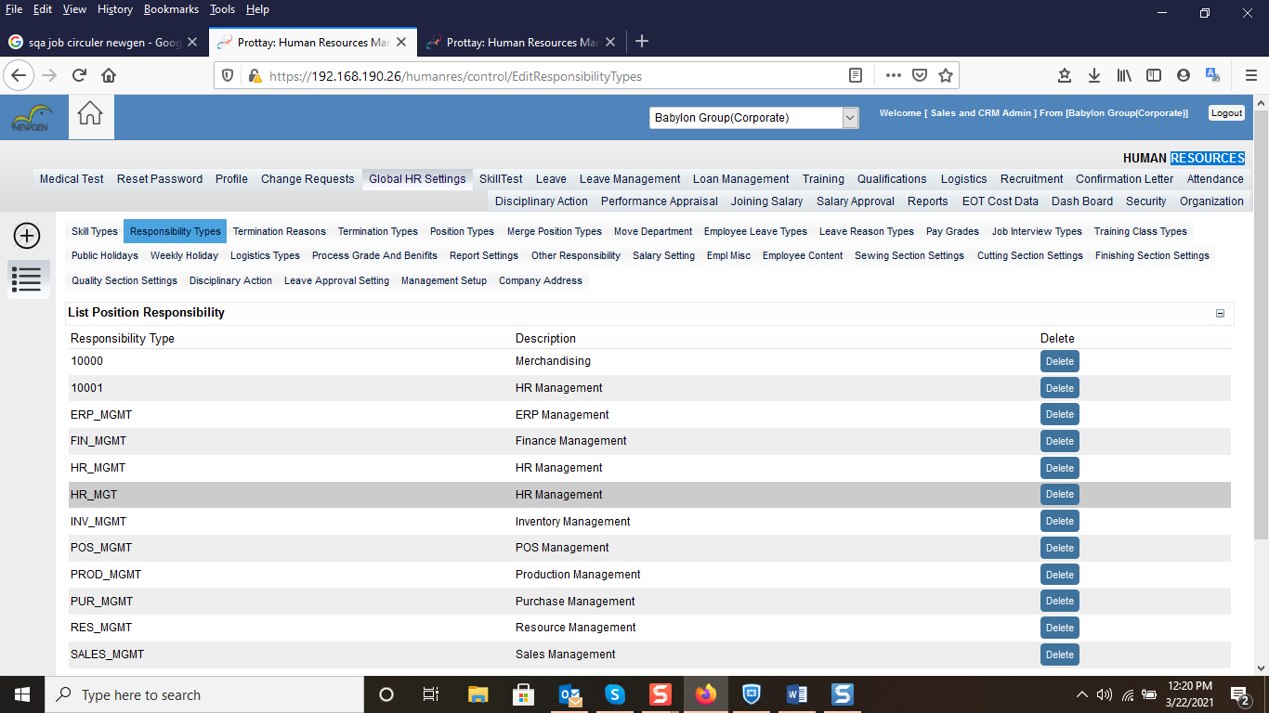

In this section User can create Responsibility type by click on create button. Where Description field is Required and Responsibility type is System generated Number.

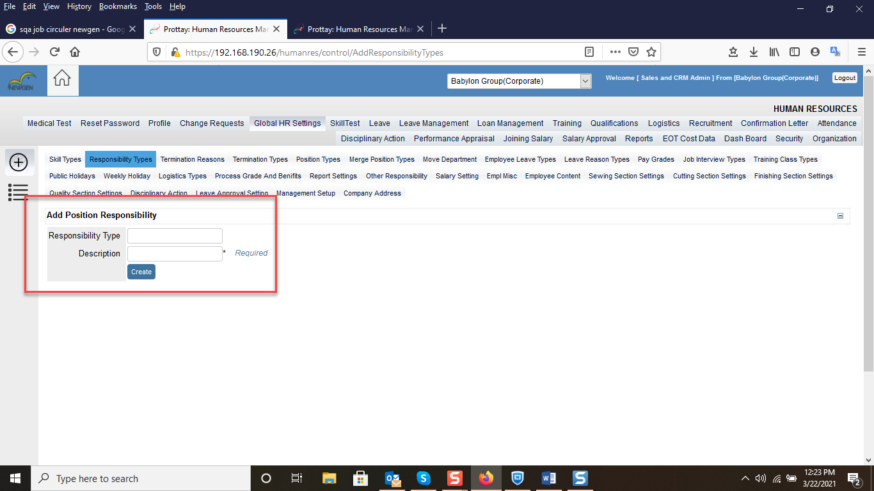

[**Termination Reasons**](https://192.168.190.26/humanres/control/EditTerminationReasons)**:**

User can create/Delete Termination Reason. If user wants to delete Existing Termination Reason, then user have to click on the delete button.

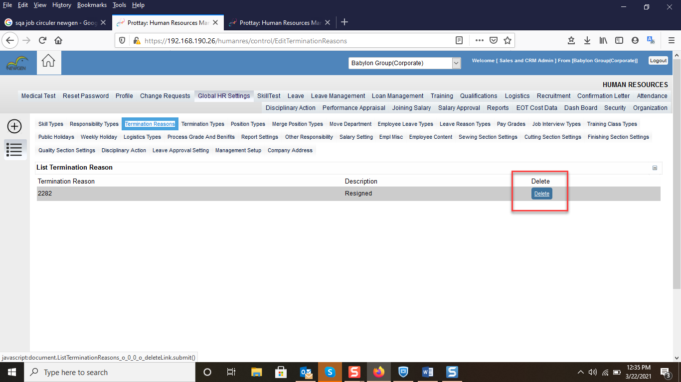

If user wants to Create Termination Reason, then user have to click on the create button. Where Description Field is Required and Termination Reason Id is system Generated.

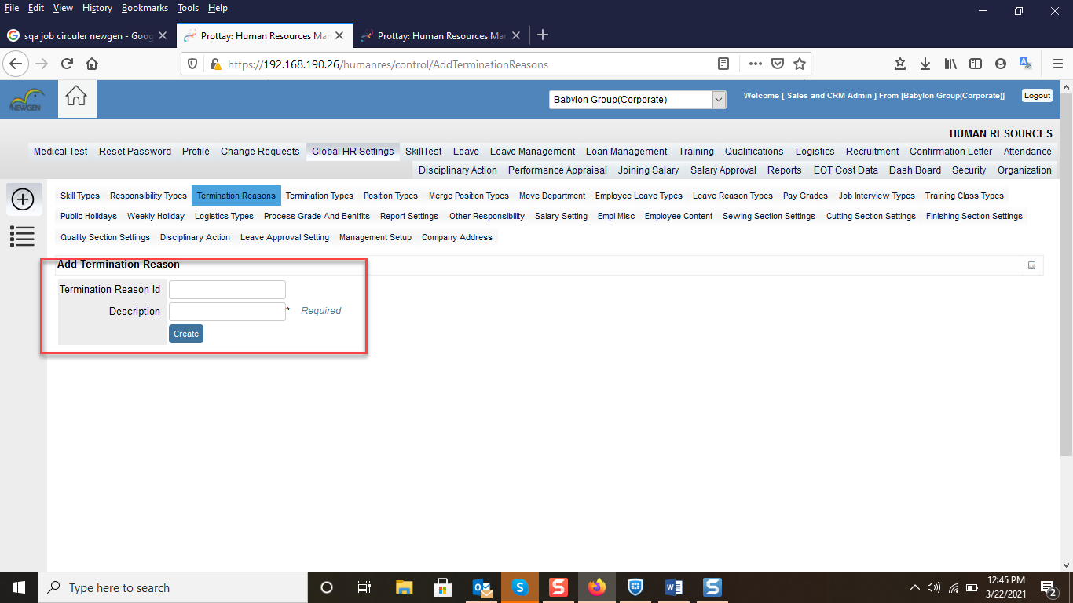

[**Termination Types**](https://192.168.190.26/humanres/control/EditTerminationTypes)**:**

User can create/Delete Termination Type. If user wants to delete Existing Termination Type, then user have to click on the delete button.

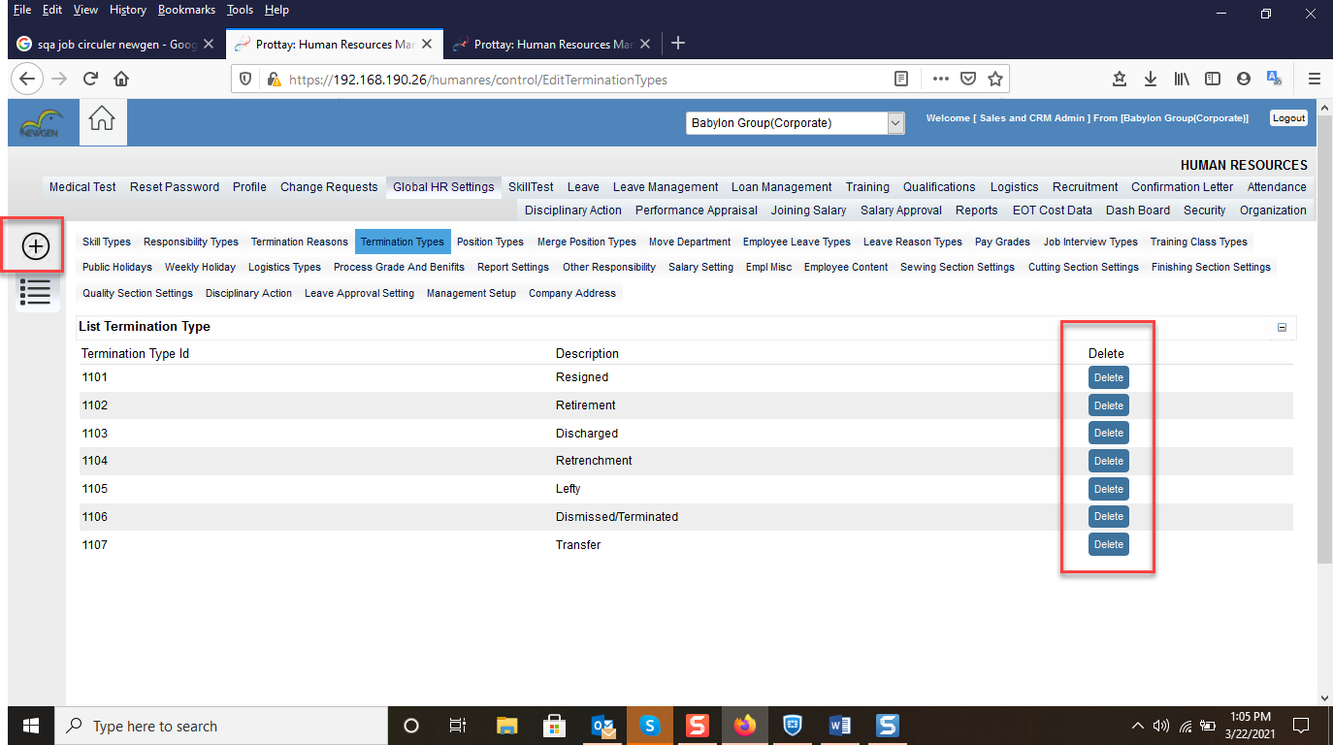

If user wants to Create Termination Type, then user have to click on the create button. Where Description Field is Required and Termination Type Id is system Generated.

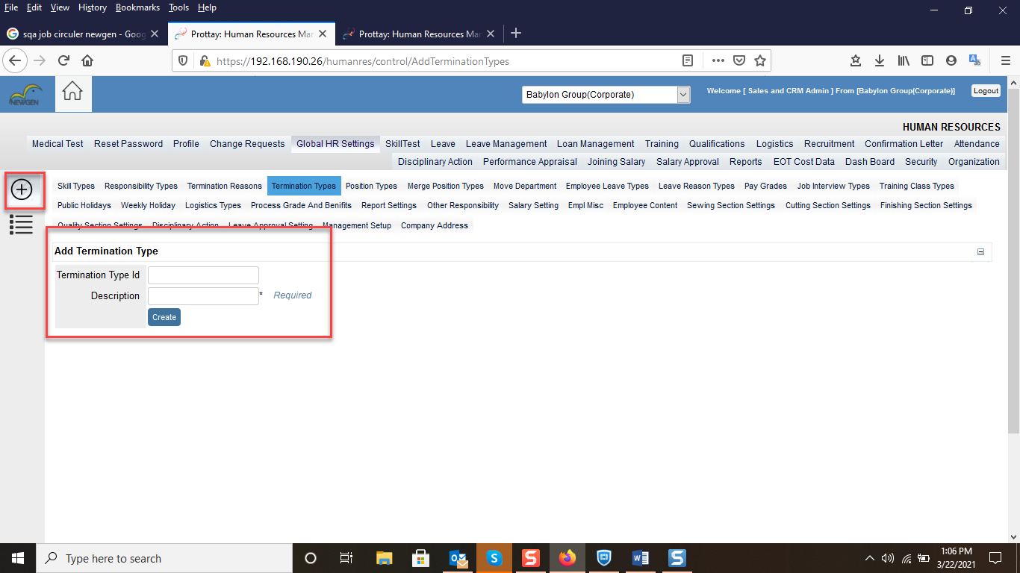

**Position Type:**

In this section user can create Position type by click on the + Button where Empl Position Type Id is optional and other field is Required.

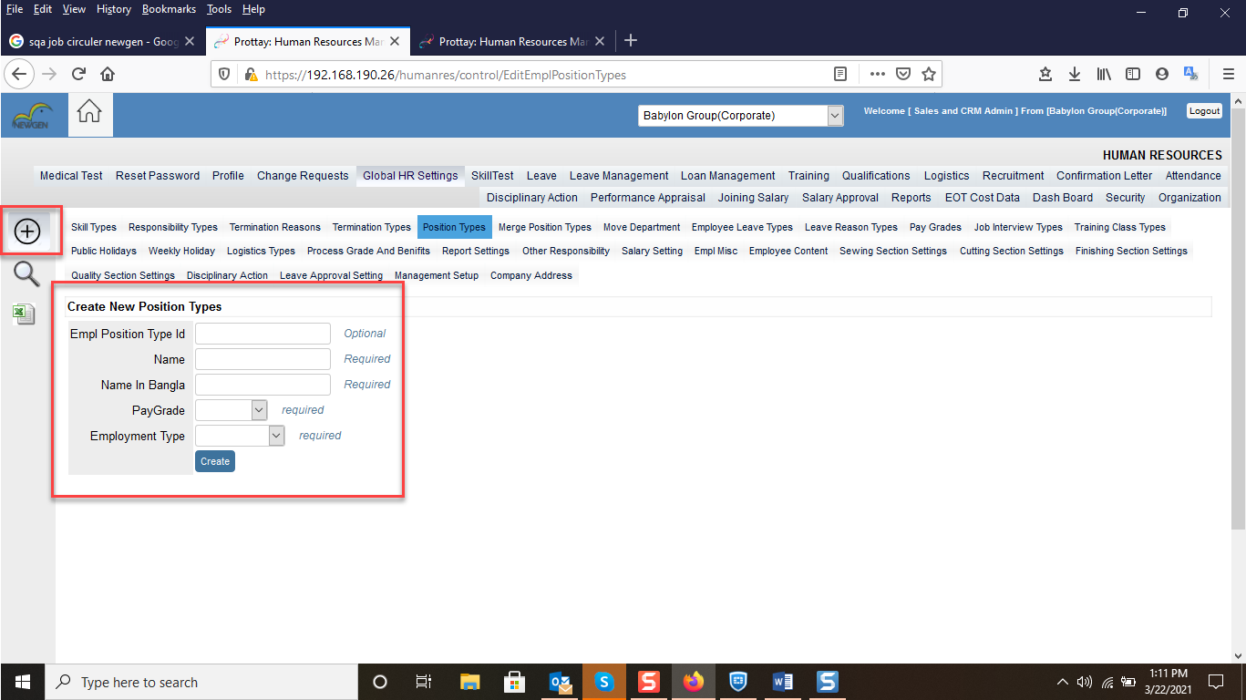

User can search Position type by click on the search Icon.

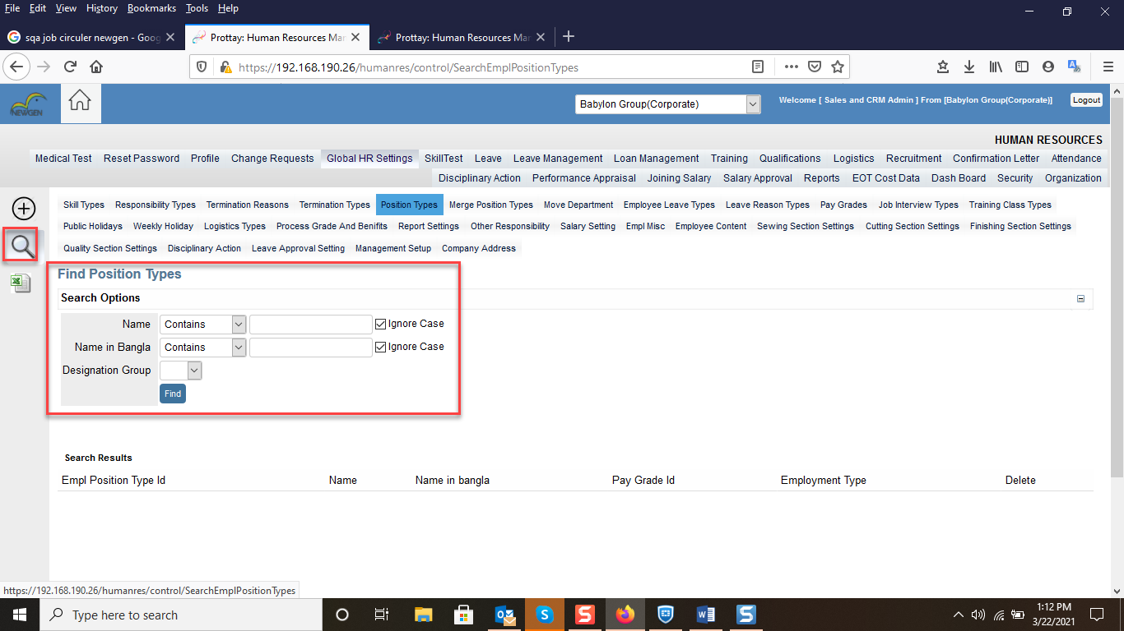

**Merge Position Types:**

User can Merge Position Types by click on the merge button.

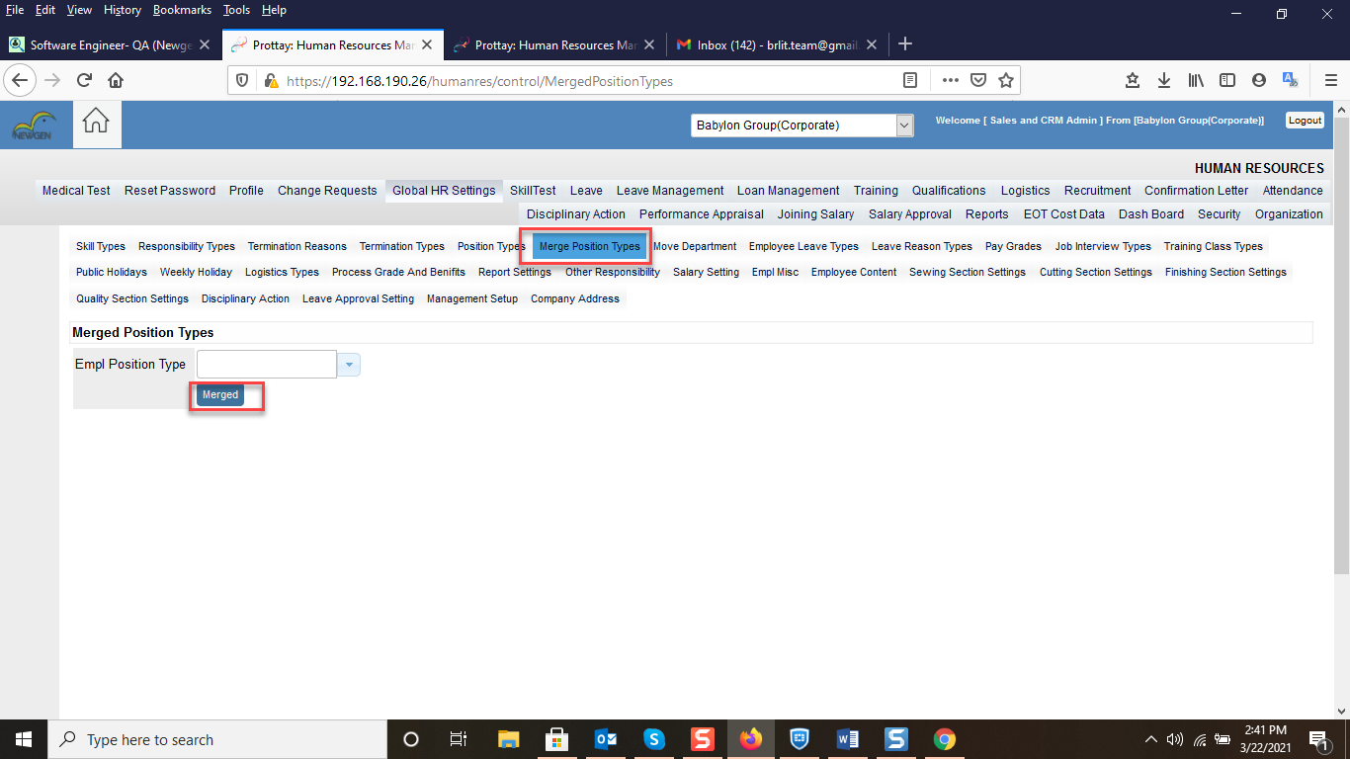

**Move Department:**

**User can move Department/Line/Section to the Another to another Department/line or section.**

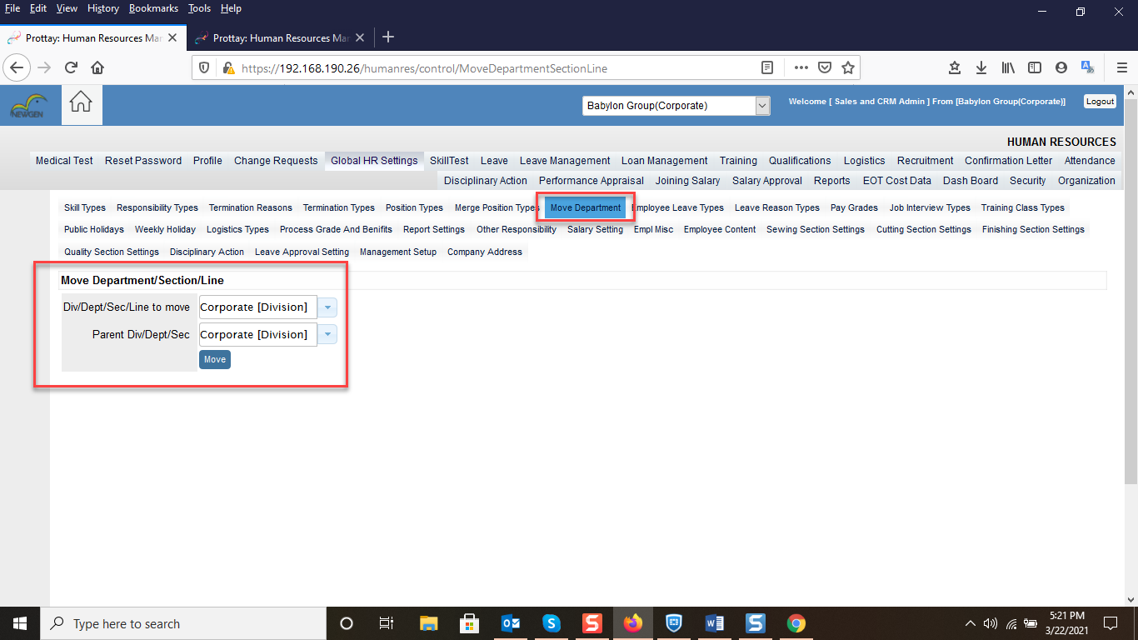

**Employee Leave Type:**

User can Create/Delete/Update Employee Leave type. If user wants to create Leave type, user have to click on the + Icon. where Max Available Leave and Description field are required and Leave Type Id System generated.

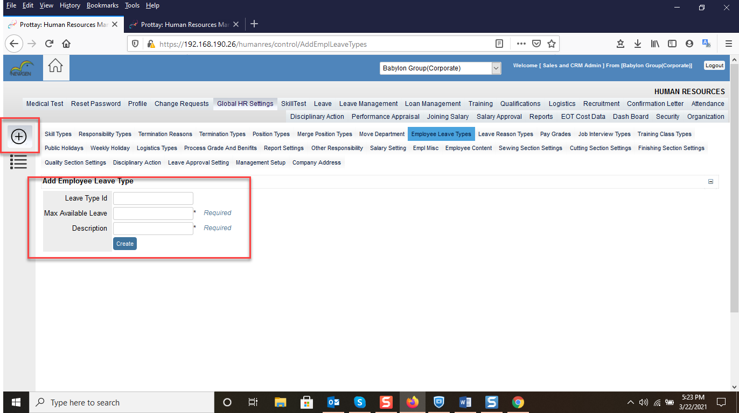

If user wants to delete Leave type, then user have to click on the Delete button.  
After click on the delete button leave type will be remove from the system.

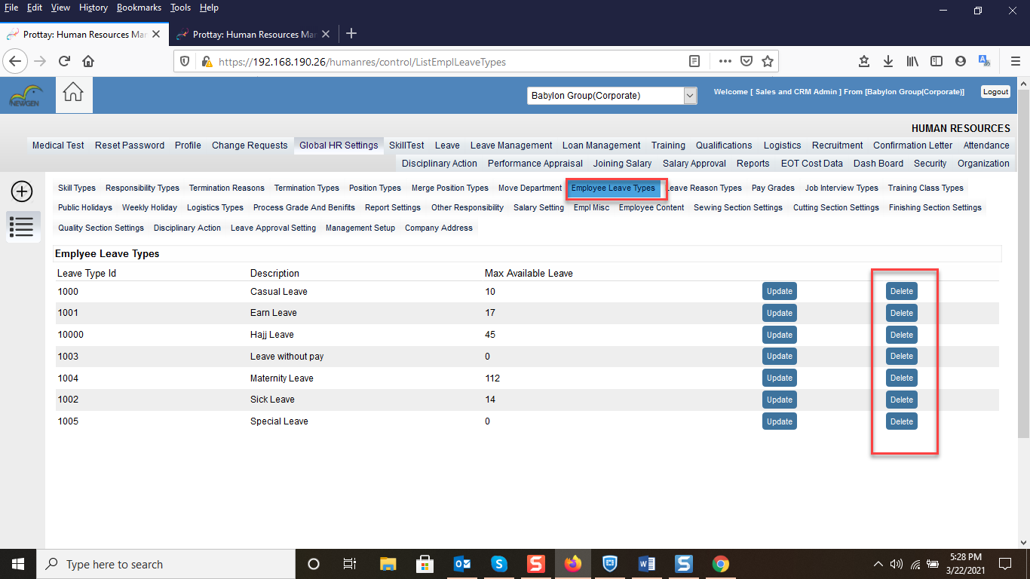

To Update Leave type, user have to click on the Update button. After Click on the Update button user will get Update screen. Where User Can Edit Max Available Leave and description. System generated number cannot editable.

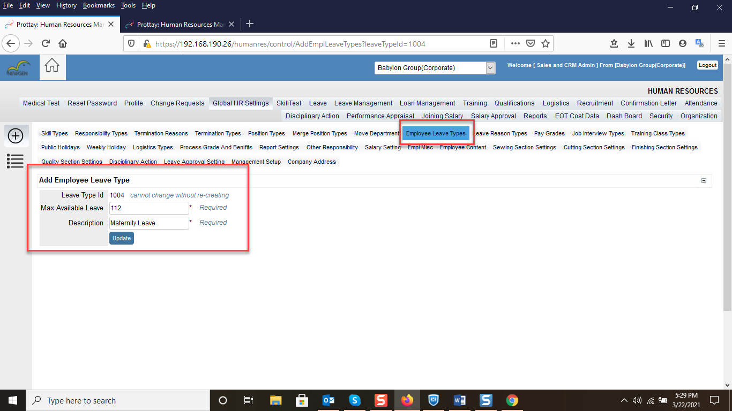

**Leave Reason Type setting:**

If user wants to set Leave reason, then user have to click on the + Icon. After click on the + icon user gets Add Employee Leave reason type. Where Leave type is optional and Description is required field. After Click on the create Button then system will create Employee Leave type.

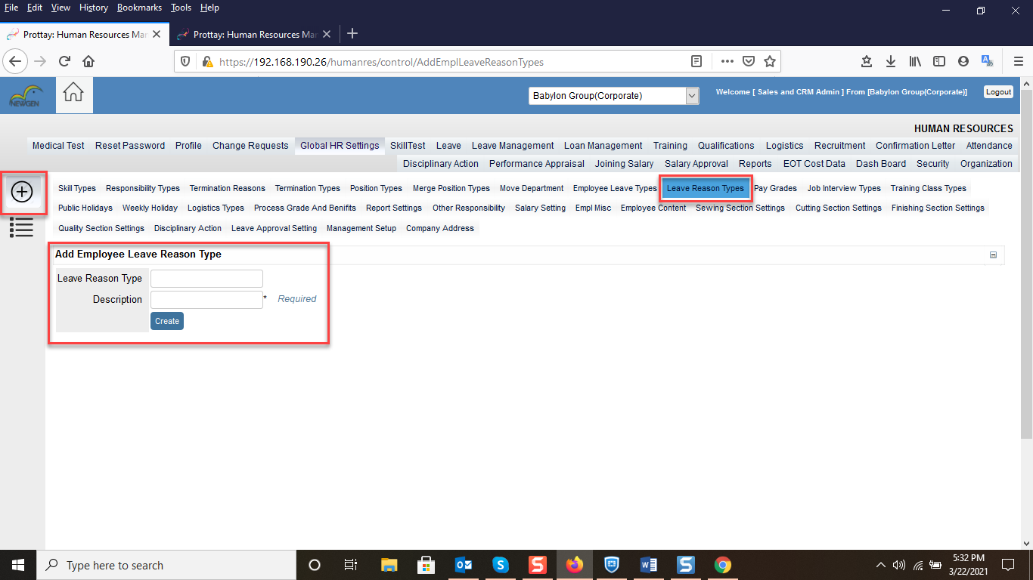

**Pay Grades:**